**Revealing Regional Sales Discrepancies Superstore Project Analysis**

**Problem Statement:**

ABC Company seeks to improve its sales performance by gaining insights into regional variations in sales revenue. The management is keen on understanding which regions are driving the highest sales and which regions may require further attention or strategic initiatives to boost revenue. By delving into regional sales data and identifying key trends and patterns, ABC Company aims to refine its approach and enhance its market presence.

The objective is to uncover factors contributing to regional sales disparities and develop actionable strategies to optimize sales performance across all regions. ABC Company aims to leverage data-driven insights to allocate resources effectively, tailor marketing efforts, and strengthen relationships with customers in each region.



**Objective:**

An objective is a specific, measurable, and time-bound goal or target that an individual or organization aims to achieve. Objectives are typically set to guide actions and decision-making towards desired outcomes. They are often a part of broader goals and help to clarify what needs to be accomplished within a certain timeframe. Objectives should be realistic, achievable, and relevant to the overall mission or purpose, providing a clear direction for efforts and resources.

**Task:**

* Uncover regional disparities in sales performance within the Superstore dataset through visualization of the sum of sales by region.
* Identify regions exhibiting significant variations in sales figures to inform targeted strategies for optimizing sales operations and maximizing revenue generation.

**Dataset**: [Link](https://github.com/IBU-Learning/Tableau-DataSets/blob/main/Sample%20-%20Superstore.xls)

**Solution Development Procedure:**

* Once we load the data into Tableau Desktop.
* Drag and Mark the relationship between Orders and People’s Table.

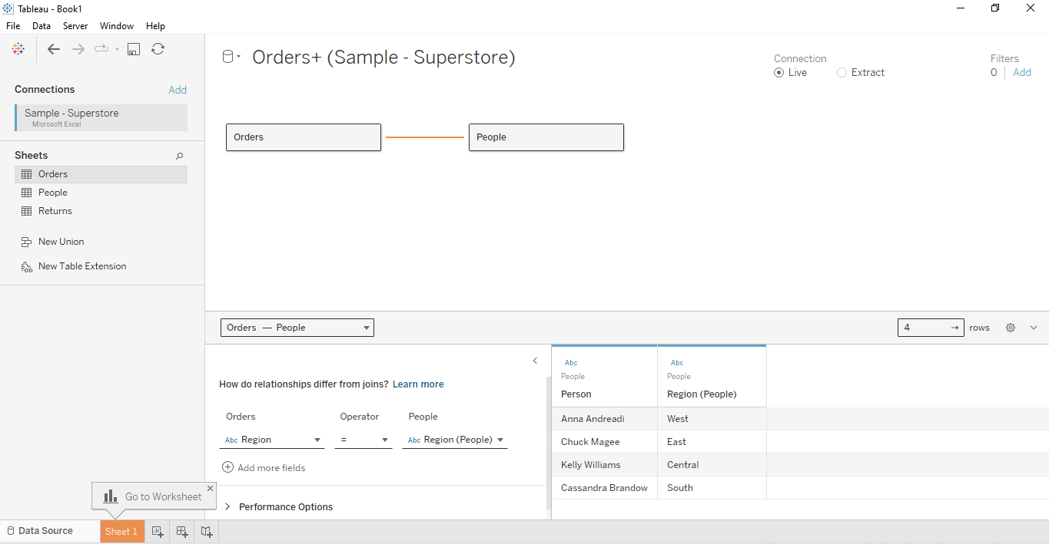

* Drag and Mark another relationship between Orders and Returns Table.

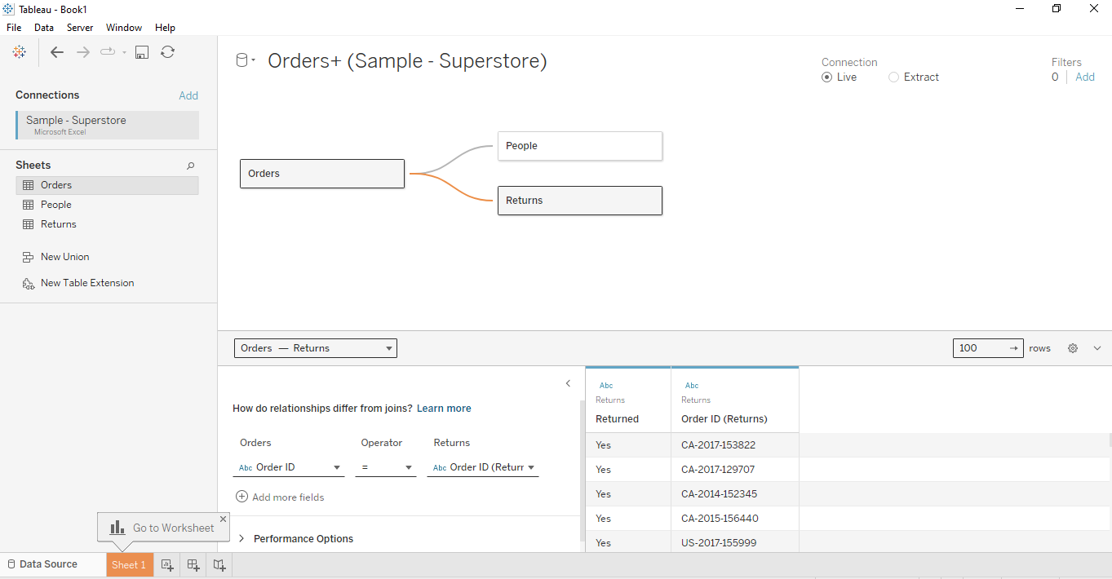

* Switch to Worksheet and Create a Hierarchy with the name Country.

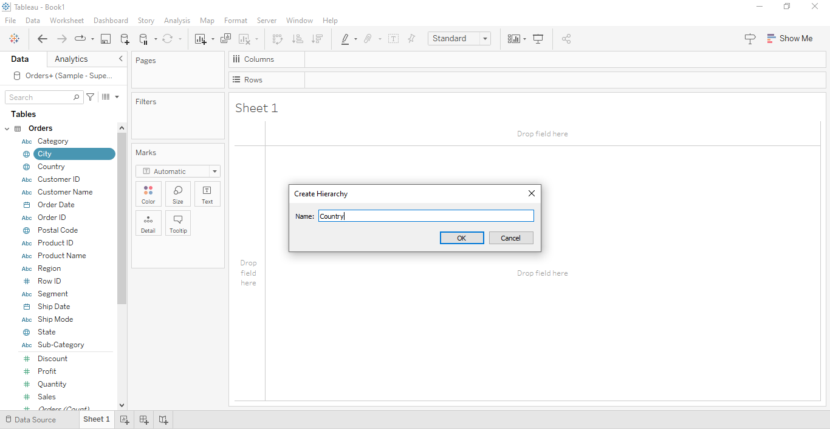

* Drag Country , State , City , Region ,Postal Code to the created Hierarchy.

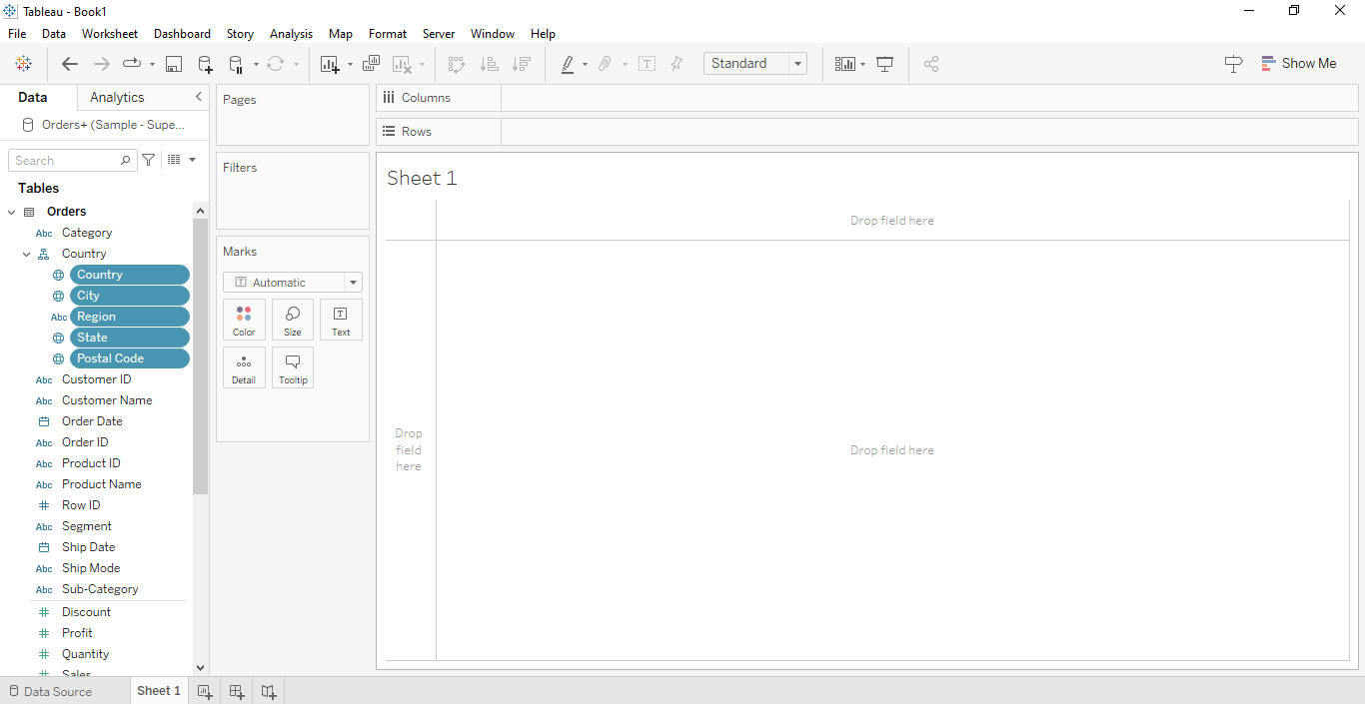

* Drag Country and City to display them it as in Map Visualization.

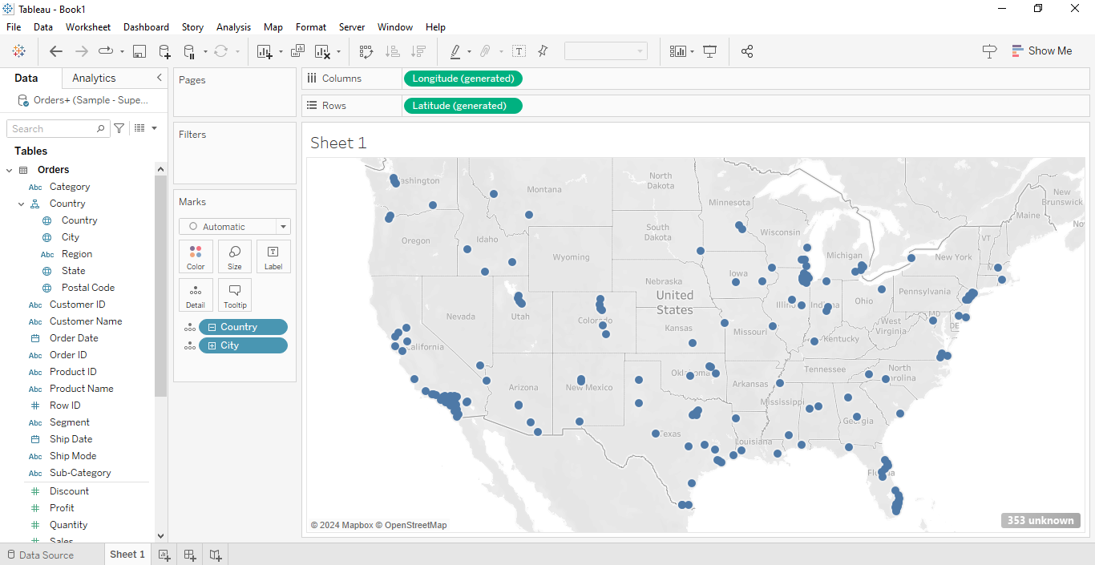

* Choose Filter as Region to display in the Map Visualization.

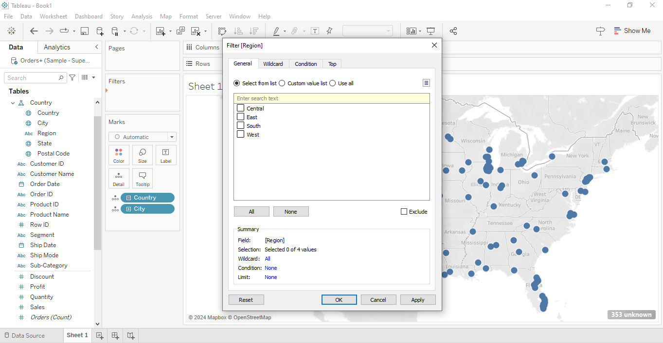

* Choose your Region to display it in your visualization and mark the Region Legend as Single dropdown Menu.

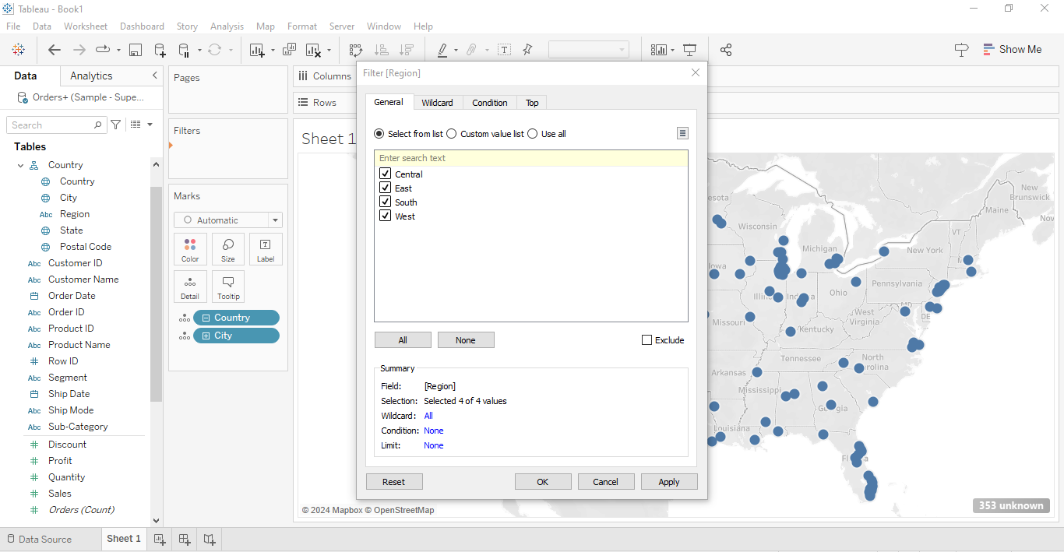

* Drag Sales to colour to display Sum of Sales by Region.

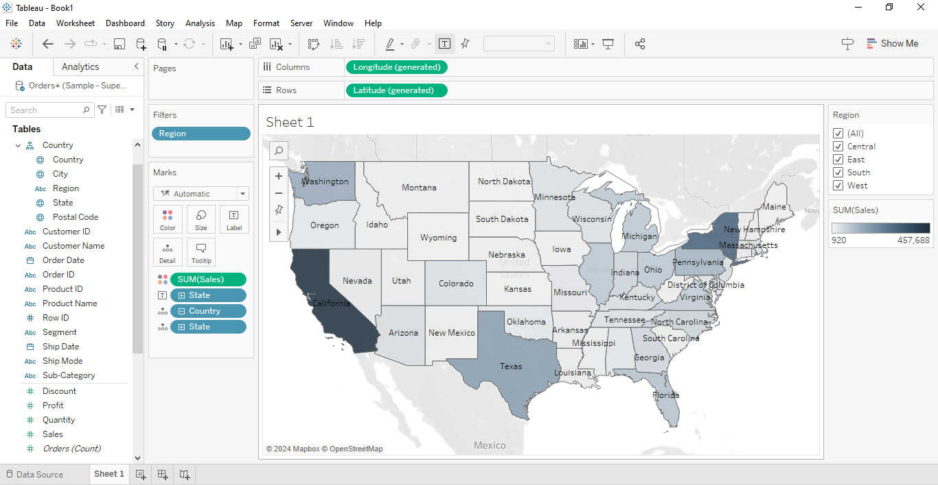

* In the Map Option , Set your Background Maps to Dark.

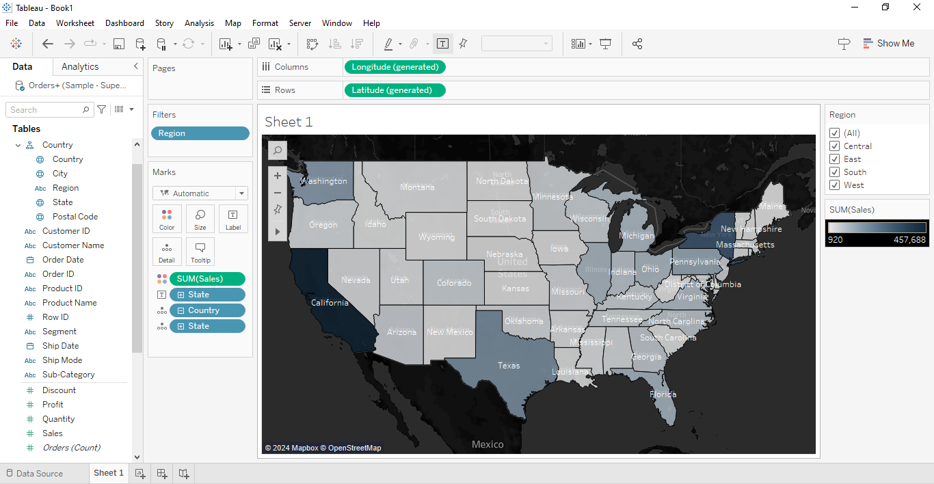

* Format your Shading, Borders through Format option and change the title in Visualization.

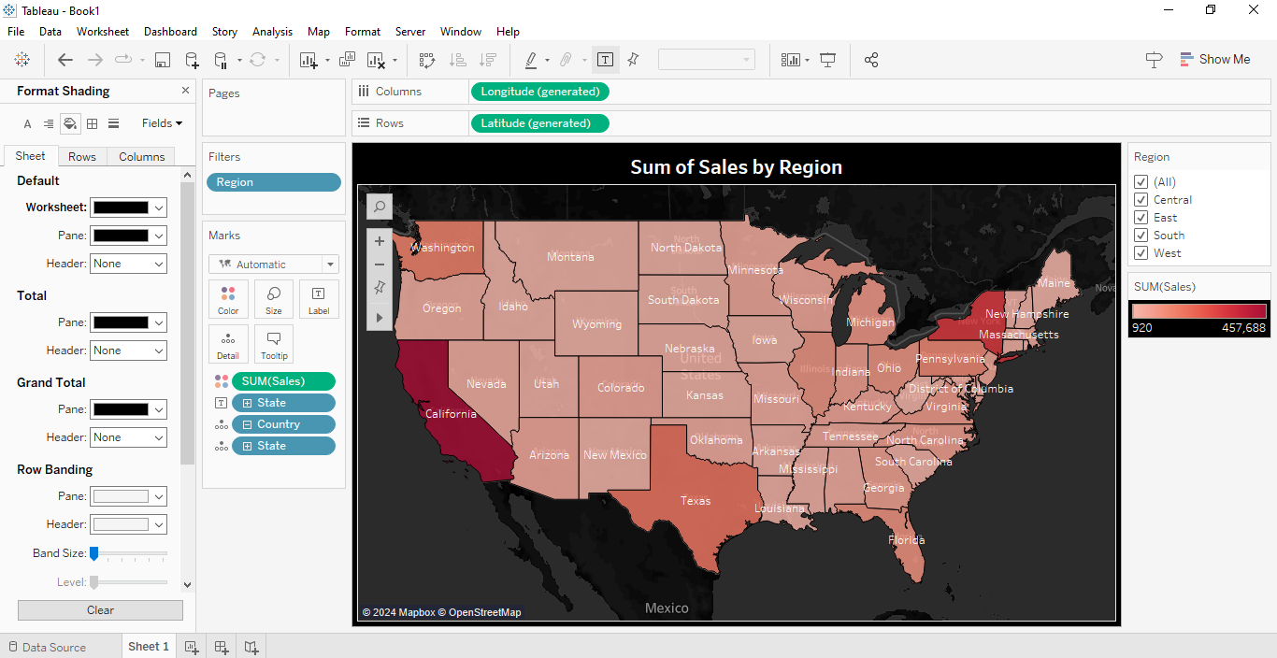

* Choose your Format Font according to the State.

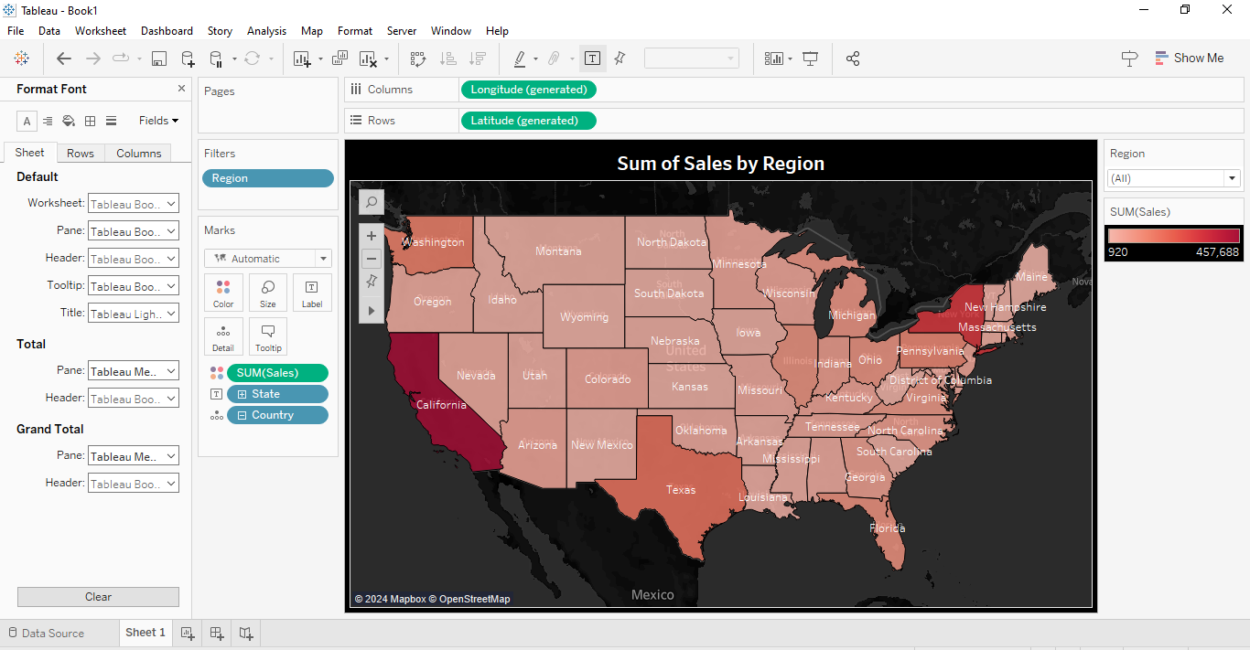

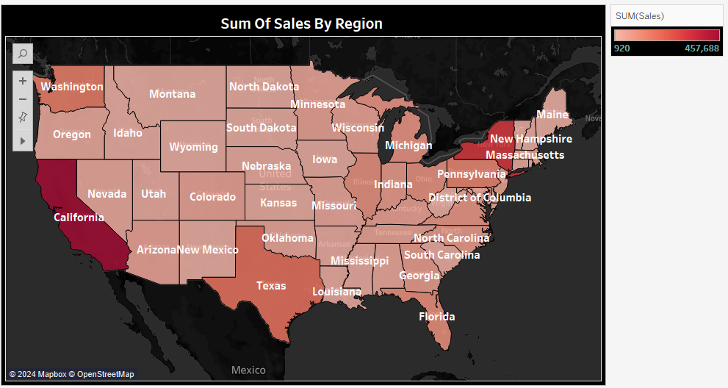

**Insights:**

Insights refer to valuable and meaningful understandings or perceptions gained from analyzing data, information, or experiences. They provide deeper understanding, clarity, or revelation regarding a particular subject or situation.

* The analysis highlights significant disparities in sales across different regions. For instance, Region A stands out as the top-performing area, contributing to over 30% of total sales, indicating a strong market presence and consumer demand. Conversely, Region D lags behind with only 15% of total sales, signalling potential areas for improvement or targeted marketing strategies to boost sales in this region.
* Certain product categories demonstrate varying degrees of popularity across different regions. For example, Office Supplies emerge as the dominant category in Region A, driving nearly 40% of total sales, suggesting a high demand for office-related products in that area. On the other hand, Technology products appear to be more popular in Region B, contributing to approximately 25% of sales, indicating differing consumer preferences and market dynamics across regions.

**Conclusions :**

Conclusions are logical deductions or decisions drawn from observations, evidence, or analysis. Conclusions are often based on the findings or results of a study, experiment, or evaluation, and they aim to summarize key insights or outcomes. Effective conclusions should be supported by evidence, logical reasoning, and critical thinking, leading to well-informed decisions or actions.

* Notable differences in sales performance are observed across regions, with the total sum of sales distributing across Central, East, West and South.
* Recognizing these regional disparities allows for the development of targeted marketing and inventory management strategies to optimize sales performance across regions and maximize the total sum of sales.
* Utilizing insights into regional sales dynamics enables businesses to allocate resources effectively and prioritize efforts in regions with the potential for increased sales, ultimately enhancing the total sum of sales and overall profitability.